Dashboard Design

Team ID | MCA
Project Name | Heart Disease Risk and Patient Health Analysis
Maximum Marks | 5 Marks

Creating an effective dashboard involves thoughtful design to ensure that the presented information is clear, relevant, and easily understandable for the intended audience. Here are some key principles and best practices for dashboard design
Activity 1: Interactive and visually appealing dashboards
Creating interactive and visually appealing dashboards involves a combination of thoughtful design, effective use of visual elements, and the incorporation of interactive features. Here are some tips to help you design dashboards that are both visually appealing and engaging for users so take care of below points
- Clear and Intuitive Layout
- Use Appropriate Visualizations
- Colour and Theming
- Interactive Filters and Slicers
- Drill-Down Capabilities
- Responsive Design
- Custom Visuals and Icons
- Use of Infographics

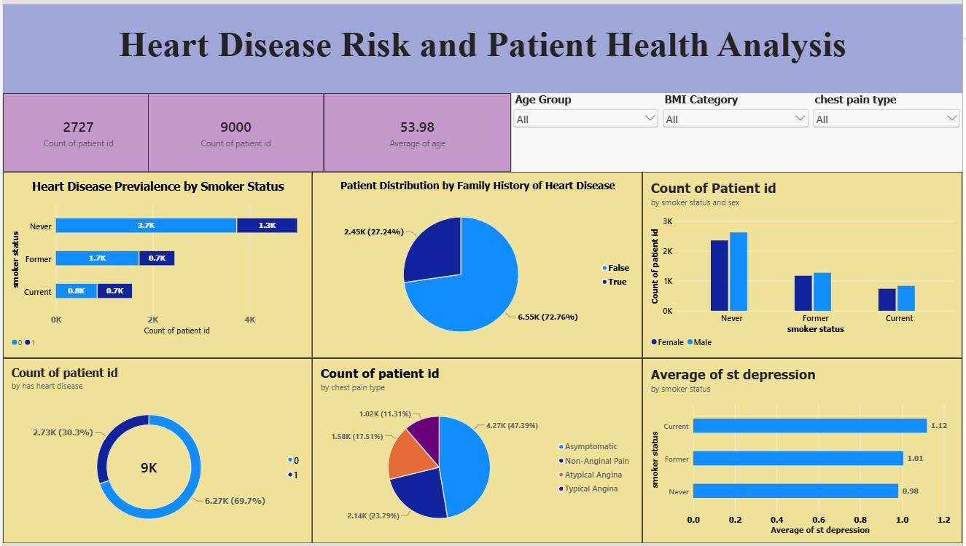
Based on the provided Heart Disease Risk and Patient Health Analysis dashboard, here are five major analytical outcomes formatted to highlight the key data insights:
- High Risk Prevalence: Out of the 9,000 total patients analyzed, 2.73K (30.3%) are diagnosed with heart disease, indicating a significant portion of the patient cohort is affected.
- Strong Genetic Link: A staggering 72.76% (6.55K) of the patient population has a family history of heart disease, pointing to a highly prevalent genetic risk factor across the dataset.
- Predominant Chest Pain Symptom: The majority of chest pain cases recorded are Asymptomatic (47.39% / 4.27K), meaning nearly half of the patients do not display classic painful symptoms, followed by Non-Anginal Pain at 23.79%.
- Gender Distribution Trends: Across all smoking statuses (Never, Former, and Current), Male patients consistently outnumber Female patients, highlighting gender-specific distribution patterns in patient enrollment.
- ST Depression Correlation: The average ST depression value—a critical cardiac marker—is highest among Current smokers at 1.12, compared to 1.01 for former smokers and 0.98 for non-smokers, suggesting a link between active smoking and higher cardiac strain metrics.

